**Members:**

1. Johann Kristoff G. Naranjo
2. Johann Daniel M. Apolonio

**Github Link:**

* + https://github.com/Uhan7/GRAP-MP

**Implementation Summary**

| **Feature** | **Summary** |
| --- | --- |
| 3D Models | 1 Player car, 2 Ghost cars, were modeled properly, All karts got their textures rendered and react with lighting. Ghost karts are also rendered with some transparency.  The plane road was textured, a grass texture was used instead of a grey plane, though the grass model was not entirely flat.  The 2 landmarks were also visible and are rendered, they also react to light.  Implemented by Johann Naranjo |
| Skybox | 2 Skyboxes were in the game, one for the daytime and one for nighttime. The daytime skybox was just the same skybox used in the projects, this is because other skyboxes didn’t seem to render properly, but the night skybox works well.  Implemented by Johann Naranjo |

|  |  |
| --- | --- |
| Lighting | Lighting was appropriate, the directional light changes in color, intensity, and direction whether it is daytime or nighttime.  all karts also have 2 spotlights in front of them when it is nighttime, the 2 spotlights for the player turn red when going backwards.  Q for morning and E for night works, with different skybox, directional light, and point lights.  Additionally, there is a spotlight in the beginning of the game that goes from red to yellow to green to indicate the start of the game.  Implemented by Johann Naranjo |
| Cameras | 1st Person and 3rd Person work fine and switching between the two work.  Camera functions for rotating third person cameras using keyboard inputs only work to rotate the Eye on itself and not around the player car.  Camera functions for rotating third person camera using mouse is absolutely funky, but works  Original Camera implemented by Johann Naranjo, camera movement implement by Johann Apolonio. |
| Player Controls | All triggers for keyboard inputs and mouse inputs work properly as intended.  Q - daytime lighting  E - nighttime lighting  W - move player car forward  S - move player car backward  A - rotate player car left  D - rotate player car right  Space - stop the other cars  Z - toggle which camera to use  Mouse with Left Click to look around    Keyboard Inputs are implemented by Johann Naranjo, Mouse Inputs are created by Johann Apolonio. |

|  |  |
| --- | --- |
| Gameplay | Gameplay functions are all located in gameplay.h and gameplay.cpp.  Upon initiation of the Gameplay class, light, objects, camera, and skybox are all initiated.  Support class “Timer” supports is used to take into account any time values needed to complete the stopwatch specs of the 3 different cars.  Gameplay won’t end when all 3 race cars cross the finish line, only the timer will declare what time all 3 cars crossed  Movement by Johann Naranjo, Timer Gameplay logic by Johann Apolonio |
| OOP | The following classes were created for the project, bullets under a certain class mean a parent-child relationship:   * Camera class   + Perspective Camera class   + Ortho Camera class (unused) * **Gameplay class (loads the game)** * Light class * Object class (both loads the model and allows for movement transformations.) * Shaders class * Skybox class * **Timer class**   The following in **bold** was created by **Johann** **Apolonio**, no bold is by Johann Naranjo |

|  |  |
| --- | --- |
| **Bonus Features** |  |
| Spot Light | A spot light was done in the place of point lights for the lights in front of the karts at night, this was done to make it more realistic so the lights have a direction.  Additionally, the starting timer with lights was also done with a spot light pointing downward to the karts.  Implemented by Johann Naranjo |
| Kart Speed Physics | This was not done:(  Well we did have something but decided not to use it because the car would nyoom so fast lol. |
| Signal Start Lights | A Spot light in the beginning is used to dictate the go signal for when all karts can start to move, including the player.  The spot light starts only counting down after a few seconds have passed to give the loading a bit more time, then, it will count down for 1 second to go from red to yellow, then 1 more second form yellow to green, afterwards, all karts may move.  Implemented by Johann Naranjo |

**Game Map**

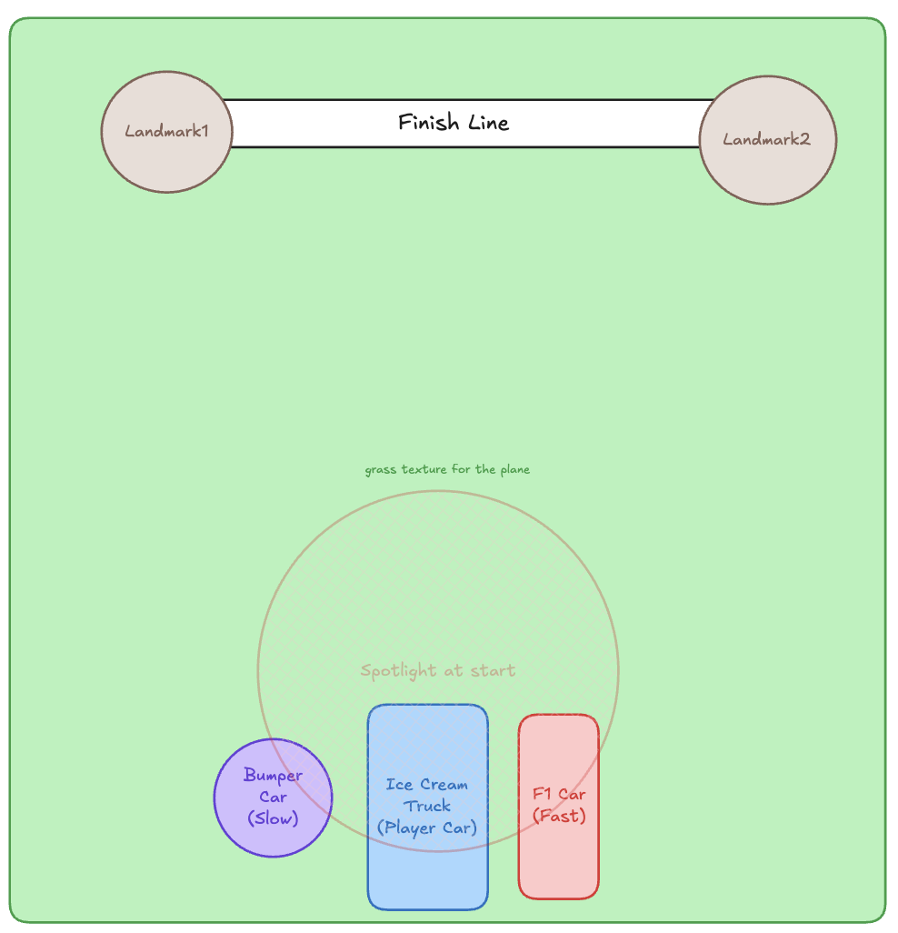

**Models**

Day Skybox Textures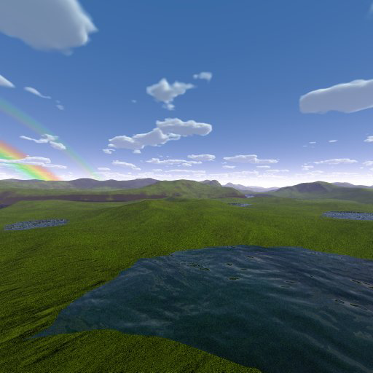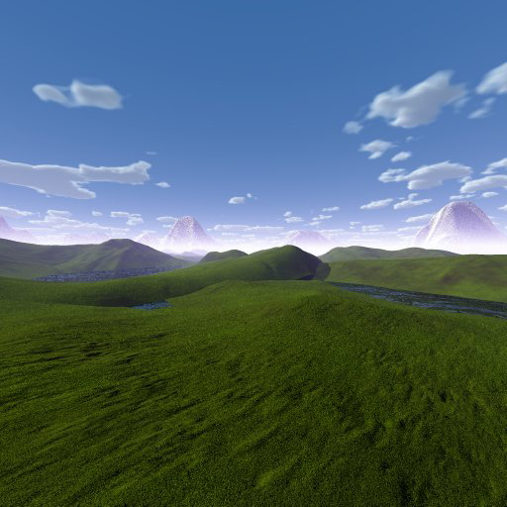

https://opengameart.org/content/night-skyboxes

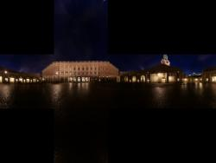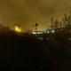

Ice Cream Car / Player Car - <https://sketchfab.com/3d-models/ice-cream-car-5ca185308bc34c26ae1cc6306754c50f>

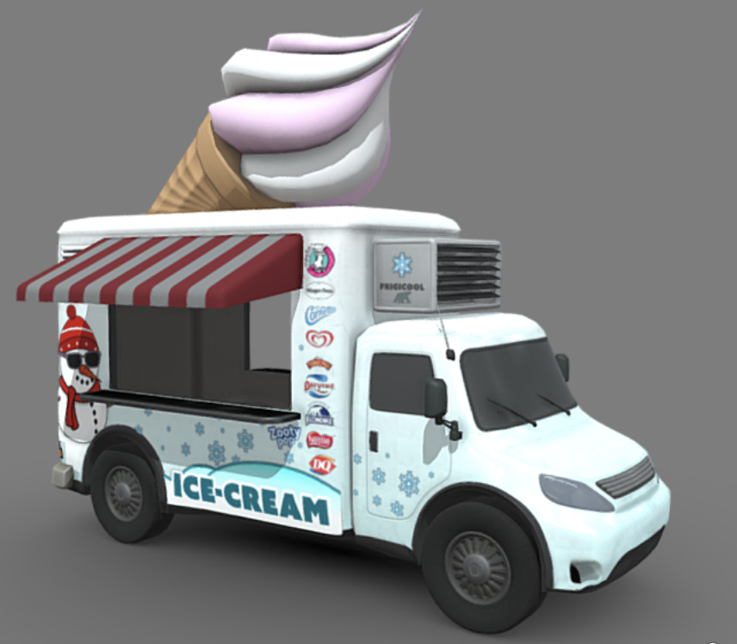

Bumper Car / Slow Car -

<https://sketchfab.com/3d-models/bumper-car-4b277e7d413648e8a1e3192b88a3f7d4>

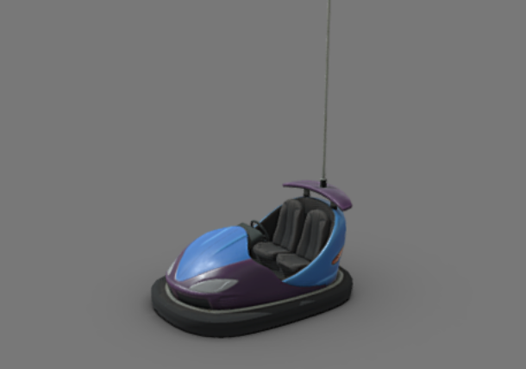

Fast Car -

<https://free3d.com/3d-model/ferrari-formula-1-72527.html>

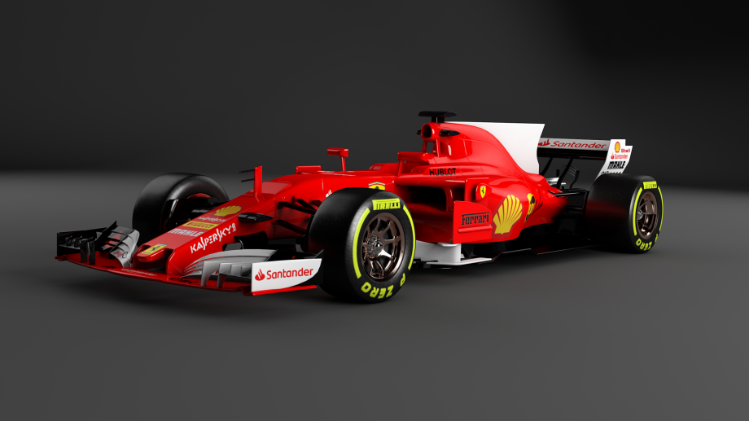

Hat - <https://sketchfab.com/3d-models/stylized-wizard-hat-f59021d602334367987bcd7657cec722>

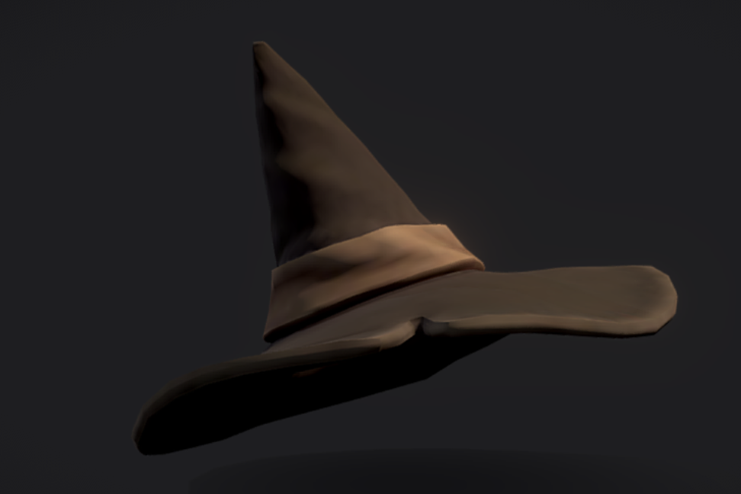

grass - https://free3d.com/3d-model/-rectangular-grass-patch--205749.html

